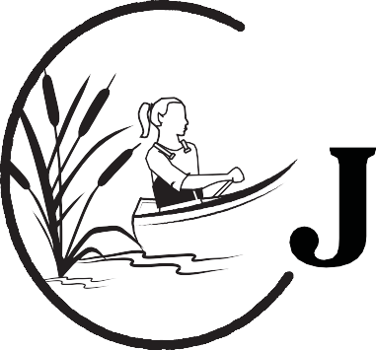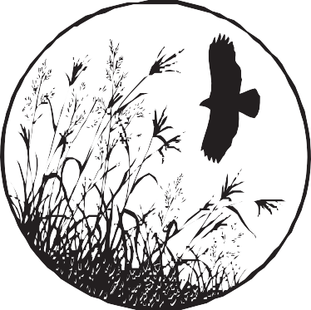

REGISTRATION IS NOW OPEN FOR 2020

July 14-16 Hickory Hills County Park south of Waterloo August 5-7 Wildwood Hills Ranch, St. Charles, IA
Outdoor Journey for Girls is a three-day, two-night workshop aimed at introducing outdoor skills to girls ages 12–15 in a supportive, learning environment where they have opportunities to try things hands-on.

Canoeing and Water Safety
Basic Orienteering
Fish and Wildlife Identification
Archery
Firearm Safety and Basic Shooting
Camping and Outdoor Survival
Game Care
Fishing and Preparing the Catch
Hunter Education Certification

Registration forms, and chaperone and sponsorship opportunities, are available at http://www.iwinr.com
or contact

Lori Eberhard at Ojcoordinator@gmail.com

